MY WEEKLY REVIEW CHECKLIST

Stage 1: Get my inputs back to zero

- Capture new ideas and nags
- Process email inbox back to zero
- Process Slack to zero
- Capture notes and actions from meetings
- Capture any receipts (wallet/mob photos)

Stage 2: Get my Second Brain up to date

- Go through Second Brain and update lists
- Review Waiting For List – for resolved, overdue or reminder actions
- Review @Waiting and @Action folders in email
- Go through Calendar, 1 week behind, 2 weeks ahead – for invites, actions or follow ups

Stage 3: Think ahead (like a Boss)

- What are my big priorities, deliverables and deadlines for the week ahead?
- Review Projects List – status, progress, timeline, add new actions to Master Actions List
- Focus on impactful work – what can I delete, be Ruthless about or renegotiate?
- When will my capacity, energy and attention be best next week – what will I do when?

Stage 4: Get ready

- Travel plans and logistics – times, tickets, hotels etc. (make it smooth next week!)
- Any printing or preparation needed for upcoming meetings?
- Get all files / papers I need ready for the coming week on my desk / in my bag
- Any people who I need to (re)confirm plans with, or talk to about upcoming activities?

Stage 5: Questions

- Check in with self: mood, motivation, morale, health, wellbeing etc.
- Am I feeling resistant towards certain tasks? How can I overcome that?
- How’s my rest, exercise, nutrition etc. going? What can I do next week to keep on track?
- Am I finding space for myself, and the people and things I love outside of work? If not, make plans now!

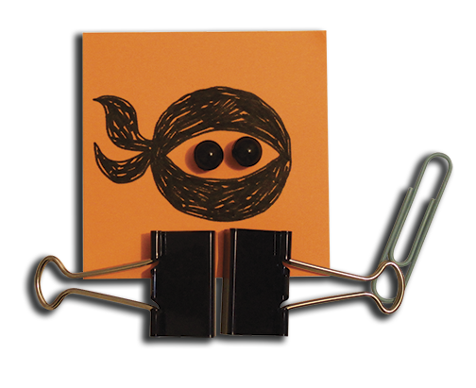
GO Ninja!
Well done on all that thinking and planning! Enjoy this moment of calm and clarity and the assurance that you are working on the most important thing right now.

